4º meeting in Valencia-Manises Democracy at school
1º morning : MONDAY 02 NOV
All countries creating and bring to Valencia-Manises:
- Video-presentation (5minutes) about how students are living the democracy at school: thoughts about how democratic our school is and how should be , …interviews, opinions, news ideas, researches in our school (students, teachers, staff..)
- EVERY STUDENTS:
To Bring a creative design , 3x3 cm, in a paper to print it in a cup, in the Pottery school
of Manises
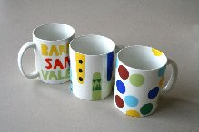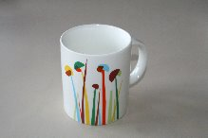

2º morning: TUESDAY 03 NOV
Activity during the meeting
- Foros in eTwinning Project: e-democracy, e-decisions, e-opinions…about different topics so… students must be registered in the twinspace

- Wall for Democracy : Big , creative and collaborative wall like a Graffiti, with principles, purposes, values of the Democracy…words, draws, pictures… Spanish school provide materialsl to do it: rights, duties, respect, human rights, dialogue, justice, equality, solidarity, responsability… words in English and in our tongue lenguages.
We can bring templates for drawing letters or words… or not…
Production: a collaborative picture and the photos-video with the process

3º morning WESNESDAY 04 NOV
Young Parliament: 1h working in groups / 1h discussion ;
Inmigration/Emigration in Europe: the past, the present and the future
Production: a video recording by the host school

In conclusión

- Video of the topic, one for each country (max.5 m)
- Design for the tap: 3x3cm, one for each student
- One Word in English and in our tongue language for each country:
template 40x40 cm ( creative design)

