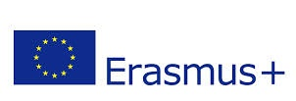

Young Voices in the European Democracies

2014-1- TK01- KA201-013069

CERTIFICATE OF ATTENDANCE

This is to certify that

Eva Mª Martínez Domínguez

Took part in the Erasmus+KA2
MULTIPLIER EVENT : ROBOTICS WORKSHOP
in Valencia-Manises, Spain, November 06, 2015

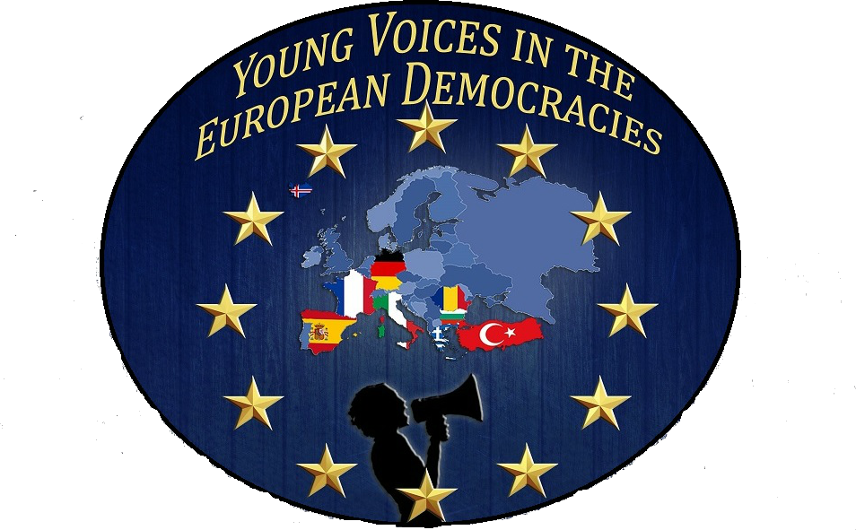

Cristina Garcia Calap, The Headmistress

Manises November 06, 2015

